Name- Jiya Tyagi

Sapid-500119743
Lab Exercise 17- Creating Secrets in Kubernetes

Creating secrets in Kubernetes is an essential practice for managing sensitive information such as passwords, OAuth tokens, and SSH keys. Let's go through a lab exercise that demonstrates how to create different types of secrets in Kubernetes.

Step 1: Create a Generic Secret

Create a secret from literal values:

kubectl create secret generic my-secret --from-literal=username=admin --from-literal=password='P@ssw0rd'

Verify the secret:

kubectl get secrets my-secret -o yaml
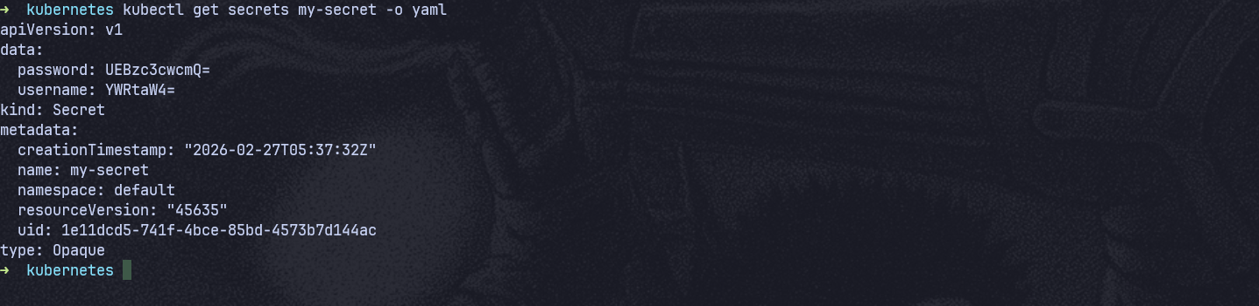

The output will be base64 encoded. To decode, you can use:

echo -n “P@ssw0rd” | base64
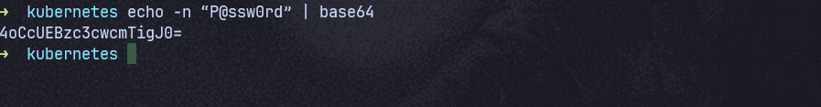

Step 2: Create a Secret from a File

Create a file with your sensitive data:

echo -n 'my-username' > ./username.txt

echo -n 'my-password' > ./password.txt
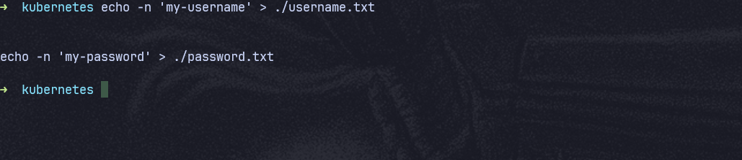
It is empty because it is encoded in base64

Create a secret from the file:

kubectl create secret generic my-file-secret --from-file=username=./username.txt --from-file=password=./password.txt

Verify the secret:

kubectl get secrets my-file-secret -o yaml
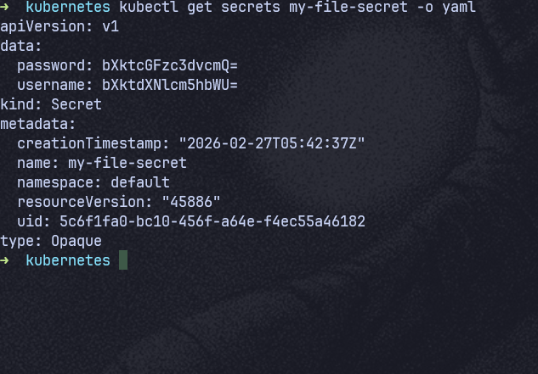

Step 3: Create a Docker Registry Secret

Create a Docker registry secret:

kubectl create secret docker-registry my-registry-secret --docker-username=<your-username> --docker-password=<your-password> --docker-email=<your-email> --docker-server=<your-docker-server>

Verify the secret:

kubectl get secrets my-registry-secret -o yaml
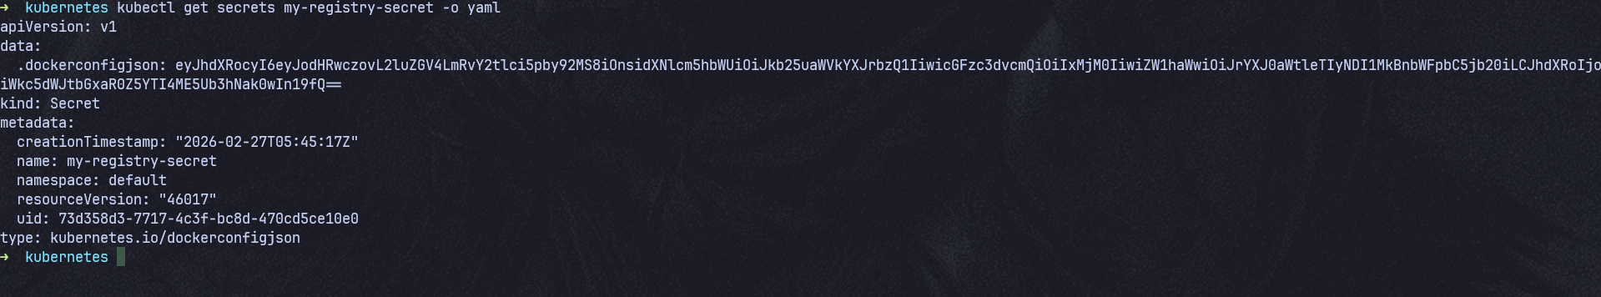

Step 4: Create a Secret Using a YAML Manifest

Create a YAML file for the secret:

Create a file named my-secret.yaml with the following content:

apiVersion: v1
kind: Secret
metadata:
name: my-manifest-secret
type: Opaque
data:
username: YWRtaW4= # base64 encoded value of 'admin'
password: UEBzc3cwcmQ= # base64 encoded value of 'P@ssw0rd'

Apply the YAML file:

kubectl apply -f my-manifest-secret.yaml
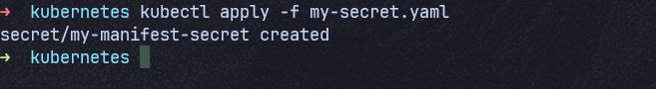

Verify the secret:

kubectl get secrets my-manifest-secret -o yaml
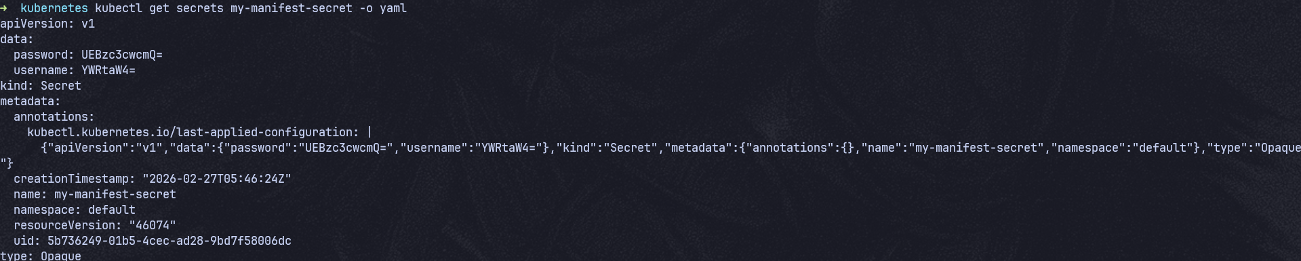

Step 5: Use Secrets in Pods

Create a pod that uses the secret:

Create a file named pod-with-secret.yaml with the following content:

apiVersion: v1
kind: Pod
metadata:
name: pod-with-secret
spec:
containers:
- name: mycontainer
image: nginx
env:
- name: USERNAME
valueFrom:
secretKeyRef:
name: my-secret
key: username
- name: PASSWORD
valueFrom:
secretKeyRef:
name: my-secret
key: password

Apply the YAML file:

kubectl apply -f pod-with-secret.yaml

Verify the pod is running and the secret is being used:

kubectl exec pod-with-secret -- printenv | grep -E 'USERNAME|PASSWORD'
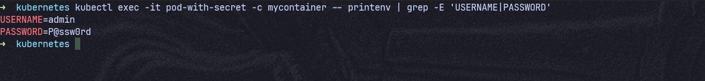

Step 7: Clean Up
Delete the secrets:
kubectl delete secret my-secret
kubectl delete secret my-file-secret
kubectl delete secret my-registry-secret
kubectl delete secret my-manifest-secret
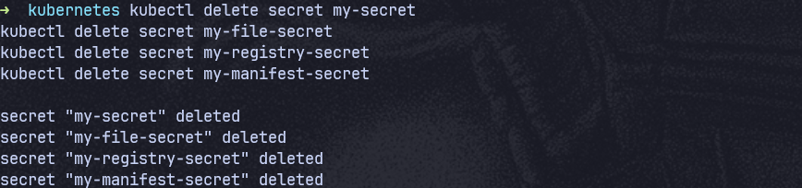

Delete the pod:
kubectl delete pod pod-with-secret
